BSC – HGP – Project Go

UI Design Document & Report

**Color**

We used the light brown color and the background as the black so the grids on the board can appear black.

So basically the reason to choose this color is that the official game of go is made on the wooden board so we tried to match the color of the wooden board

**Location**

We kept the location of the board as it is as a main widget and then we put the score board on the right side as a dockright widget

**ScoreBoard**

On the scoreboard the first thing that you will see is the instructions which will help the user to use the following features Pass move, Reset game or End Game. With the help of keyboard keys which are P, R and E accordingly.

Below instructions we have a Qlabel which shows the current turn which can be black or white, based on the current turn we have set the background of the label to change according to the turns. If its blacks turn then the background color will be black and if its white, then the background color will be white.

Click location is next which is kept as default just with the border radius and padding to keep it according to the theme

Time Remaining it is the time remaining for each turn to end if your time runs out then you automatically lose the game. For the first move of the game time is 120 after that each move have 40 seconds and the color of the font turns red just to make it look more obvious as compare to other widgets.

Below that four different labels are used to show the number of black and white stones that have been captured and also the number of territories taken by both players is displayed in the Qlabel as well

**Board**

We kept the board size as 7 x 7 as required. In the Drawboard() method basically we used the board array and made 7 rects in rows and 7 rects in columns. This was the most time consuming for us as we couldn’t get the board as a grid the first board that we build looked like this

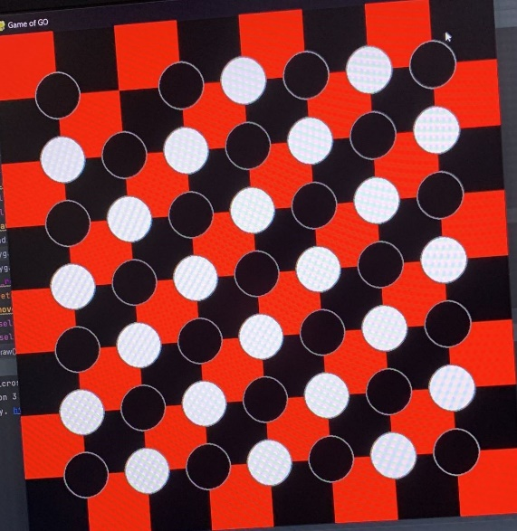

This was more like a chess board which was selected by us then we used the code that was provided and with that template we made the board which we have right now.

We found out that if keep same color for all the boxes then leave the background as black we can actually make grid format board just like the game of go requires

After making the board next challenge was how to draw pieces on the board so first thing was to draw the pieces and on the grids so we use the painter.translate and some of the code given to us already we figured that out.

After we had to check for game logic valid moves, suicide rule, KO rule before placing the stone on the board We used the notification method to send alerts to the user which basically displays a dialogue box with the message. For example if the position is not available the following error appears

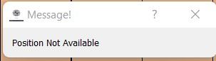

We implemented pass move, end game, and reset game methods in the board class so we can call them and we used the Keyboard events in the go class and we connected the following methods with the key press events and it works absolutely fine.

Game logic

This is basically the backbone of the whole application because without this we cant perform any of the actions in the game so in this class we spent the most amount of time and I took us 2 weeks just to finish this class we used some online help with the game logic as well as we used help from some YouTube tutorials

For the game logic we had to make an extra class called liberties which basically gives the liberties and let us set the liberties and then we use this class to capture the stones for example we check the whole board and all the stones that have 0 liberties we capture them

# Screen Shots of Working/Not Working Features

|  |
| --- |
| **Task 1 (1 image with description + what is working/not working)** |
| Fully Functional  Score Board  All the features on the scoredboard they are all functioning perfectly. The captures and territories are updating automatically after every event. And time also keeps running and if the players run out of time the game automatically declares other player as a winner and the game restarts.  And the current turn also updates itself after every event of placing the stone |

|  |
| --- |
| **Task 2 (6 images of working Menus/buttons/Labels including description + what is working/not working)** |
| QDialogBox  Notifications  Diaglog box is used as a notifications for the user for the following functions    a move is passed  game is ended  scores of black and white players  winner is declared  position not available (suicide move or KO move) |
|  |

|  |
| --- |
| **Task 3 (2 images + what is working/not working)** |
| Overall game works absolutely perfect no broken feature is added game should perfectly with correct libraries and python 3.9 |

|  |
| --- |
| **Task 4 (2 images + what is working/not working)** |
| Glowing of the pieces ( not working ) we were not able to do that task as it was the requirement of the team that have 3 members in it. |